Functional Models
“Assumption Dependency & Impact Tracking System (ADITS)”
ANIL KUMAR REDDY VANTERU, Systems Analyst
March 3, 2026

- Use Case Diagram
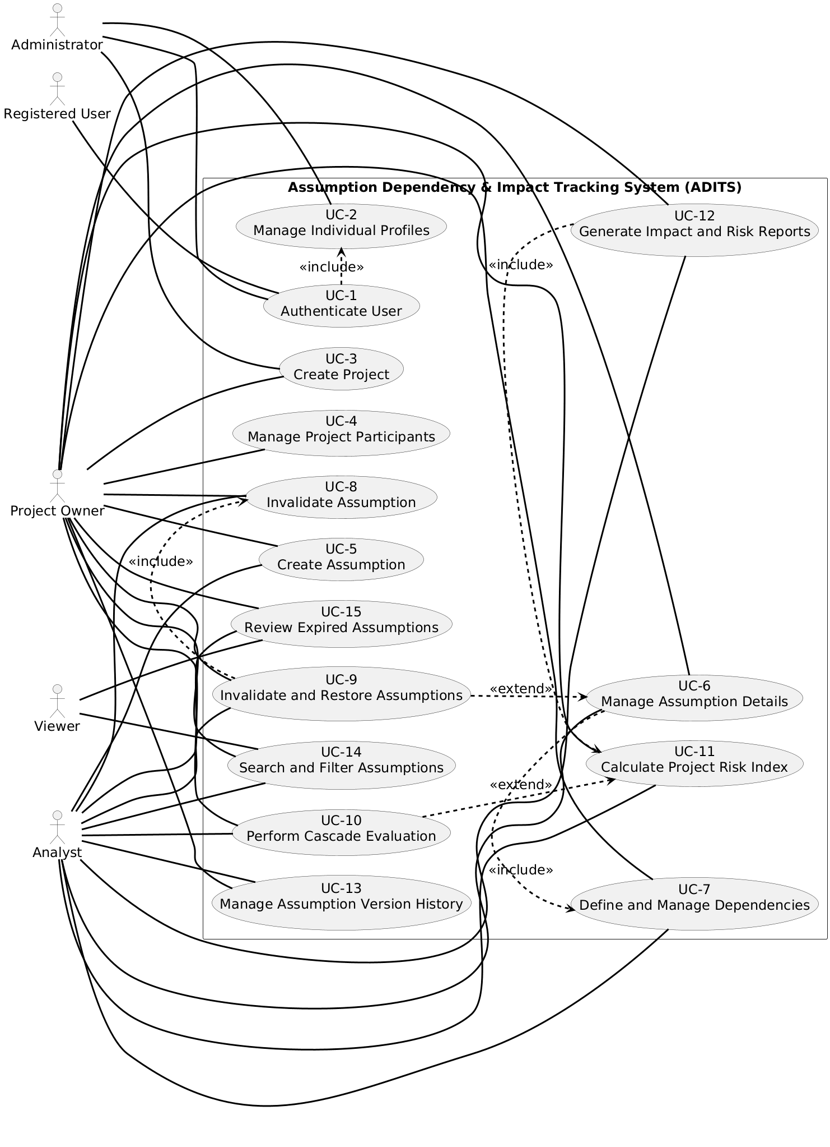
Diagram 1: Use Case Diagram for “Assumption Dependency & Impact Tracking System (ADITS)”
- Use Case Description
Use Case - 1
Use Case Name: Authenticate User |  | ID:UC1 | Importance Level: High
Primary Actor: Registered User (Administrator, Project Owner, Analyst, Viewer) | Use Case Type: Essential
Stakeholders and Interests:
Registered users require secure authentication to ensure that only authorized individuals can access project and assumption data. The organization requires protection of sensitive project information, dependency structures, risk calculations, and audit records. Proper authentication enforces role-based access control and preserves system integrity.

Brief Description: This use case allows a registered user to sign in to the Assumption Dependency & Impact Tracking System (ADITS) using a valid username and password. The system verifies credentials, confirms account status, and grants access according to the user’s assigned role.
Trigger: User opens the system and submits login credentials.
Type: External
Relationships:
Association: Administrator, Project Owner, Analyst, Viewer
Include: None
Extend: None
Generalization: Administrator → Registered User, Project Owner → Registered User, Analyst → Registered User, Viewer → Registered User
Normal Flow of Events:
1. User navigates to the system login page.

2. User enters username and password.

3. System encrypts and validates the credentials against stored user records.

4. System verifies that the account is active.

5. System identifies the user’s assigned role.

6. System grants access and displays the appropriate dashboard based on the user’s role.

SubFlows:
S-1: If the user selects “Change Password,” the system prompts the user to enter the current password and a new password, validates the new password according to security rules, and updates it in the database.
Alternate/Exceptional Flows:
1. If the entered credentials are invalid or the account is not active, the system denies access and displays an authentication error message.

This use case description is covering the requirements – FR-36 Sign In, FR-37 Change Password.
Use Case - 2
Use Case Name: Manage User Accounts |  | ID:UC-2 | Importance Level: High
Primary Actor: Administrator | Use Case Type: Operational
Stakeholders and Interests: The primary stakeholder is the Administrator, who is responsible for maintaining system security and user access control. The organization requires proper user account management to ensure that only authorized individuals can access project data and perform permitted actions according to their assigned roles.
Brief Description: This use case allows an Administrator to create user accounts, assign roles (Administrator, Project Owner, Analyst, Viewer), and deactivate user accounts. It ensures proper role-based access control within the system.
Trigger: Administrator selects the “Manage Users” option from the system administration menu.
Type: External
Relationships:
Association: Administrator
Include: UC-1 Authenticate User
Extend: None
Generalization: None
Normal Flow of Events:
1. Administrator accesses the user management interface.

2. Administrator selects an action: Create User or Deactivate User.

3. Administrator enters or selects required user information, including role assignment.

4. System validates the entered data.

5. System saves the user account information and confirms successful completion.

SubFlows:
S-1: If creating a new user, the system encrypts the password before storing it in the database.
Alternate/Exceptional Flows:
1. If required information is missing or invalid, the system displays an error message and requests correction before saving.

This use case description is covering the requirements – FR-34 Create User Account, FR-35 Deactivate User Account.

Use Case - 3
Use Case Name: Manage Projects |  | ID:UC-3 | Importance Level: High
Primary Actor: Administrator, Project Owner | Use Case Type: Operational
Stakeholders and Interests: Administrators and Project Owners require the ability to create, update, and control project records to ensure proper organization of assumptions and risk evaluations. The organization requires structured project management to maintain accurate ownership, prevent unauthorized modifications, and preserve data integrity.
Brief Description: This use case allows an Administrator to create new projects and assign a Project Owner, and allows a Project Owner to update project details. It also allows an Administrator to deactivate a project to prevent further modifications.
Trigger: Administrator or Project Owner selects the “Manage Projects” option from the system menu.
Type: External
Relationships:
Association: Administrator, Project Owner
Include: UC-1 Authenticate User
Extend: None
Generalization: None
Normal Flow of Events:
1. Actor opens the project management interface.

2. Actor selects an action: Create Project, Update Project, or Deactivate Project.

3. Actor enters or modifies project information (name, description, start date, owner assignment).

4. System validates the entered information.

5. System saves the changes and confirms successful completion.

SubFlows:
S-1: If creating a new project, the system assigns the selected Project Owner and initializes an empty assumption set for the project.
Alternate/Exceptional Flows:
1. If required project information is missing or invalid, the system displays an error message and prevents saving until corrections are made.

This use case description is covering the requirements – FR-1 Create Project, FR-2 Assign Project Owner, FR-3 Deactivate Project.

Use Case - 4
Use Case Name: Manage Project Membership |  | ID:UC-4 | Importance Level: High
Primary Actor: Project Owner | Use Case Type: Operational
Stakeholders and Interests: The Project Owner requires the ability to control which users have access to a project. Proper membership management ensures that only authorized Analysts and Viewers can access project data, maintaining security, accountability, and controlled collaboration.
Brief Description: This use case allows a Project Owner to add Analysts or Viewers to a project and remove them when necessary. It ensures that project access is properly assigned and maintained according to role-based permissions.
Trigger: Project Owner selects the “Manage Project Membership” option within a selected project.
Type: External
Relationships:
Association: Project Owner
Include: UC-1 Authenticate User, UC-3 Manage Projects.
Extend: None
Generalization: None
Normal Flow of Events:
1. Project Owner opens a specific project.

2. Project Owner selects the option to add or remove a member.

3. Project Owner selects a user and assigns or removes the role of Analyst or Viewer.

4. System validates that the user exists and is eligible for assignment.

5. System updates project membership and confirms successful completion.

SubFlows:
S-1: If adding a user, the system verifies that the user account is active before assigning project access.
Alternate/Exceptional Flows:
1. If the selected user does not exist or is already assigned to the project, the system displays an error message and prevents duplicate or invalid assignment.

This use case description is covering the requirements – FR-5 Add Analyst, FR-6 Add Viewer, FR-7 Remove Analyst or Viewer.

Use Case - 5
Use Case Name: Create Assumption |  | ID:UC-5 | Importance Level: High
Primary Actor: Project Owner, Analyst | Use Case Type: Operational
Stakeholders and Interests: Project Owners and Analysts require the ability to formally document planning assumptions within a project. Proper assumption creation ensures structured documentation, accountability, risk evaluation accuracy, and traceability of project decisions.
Brief Description: This use case allows a Project Owner or Analyst to create a new assumption within a selected project by specifying description, category, confidence level, impact weight, and optional expiration date.
Trigger: Project Owner or Analyst selects the “Create Assumption” option within a project.
Type: External
Relationships:
Association: Project Owner, Analyst
Include: UC-1 Authenticate User, UC-3 Manage Projects
Extend: None
Generalization: None
Normal Flow of Events:
1. Actor opens a selected project.

2. Actor selects the option to create a new assumption.

3. Actor enters assumption details including description, category, confidence level, impact weight, and optional expiration date.

4. System validates that numeric values fall within predefined ranges.

5. System saves the new assumption and confirms successful creation.

SubFlows:
S-1: Upon creation, the system assigns the assumption a default status of “Valid” and records the creation date and time for audit purposes.
Alternate/Exceptional Flows:
1. If required fields are missing or numeric values are outside allowed ranges, the system displays an error message and prevents saving until corrections are made.

This use case description is covering the requirements – FR-8 Create Assumption (Project Owner), FR-9 Create Assumption (Analyst).

Use Case - 6
Use Case Name: Update Assumption |  | ID:UC-6 | Importance Level: High
Primary Actor: Project Owner, Analyst | Use Case Type: Operational
Stakeholders and Interests: Project Owners and Analysts require the ability to modify assumption attributes as project conditions change. Proper updates ensure accurate risk evaluation, transparency, and historical traceability of planning decisions.
Brief Description: This use case allows a Project Owner or Analyst to modify an existing assumption’s confidence level, impact weight, expiration date, owner assignment, or status within a selected project.
Trigger: Project Owner or Analyst selects an existing assumption and chooses the “Update” option.
Type: External
Relationships:
Association: Project Owner, Analyst
Include: UC-1 Authenticate User, UC-13 Manage Assumption Version History
Extend: None
Generalization: None
Normal Flow of Events:
1. Actor selects an assumption within a project.

2. Actor chooses to modify one or more assumption attributes.

3. Actor enters updated values.

4. System validates updated data according to predefined rules.

5. System saves the updated assumption information.

SubFlows:
S-1: Before saving changes, the system creates a new version record of the assumption to preserve historical data.
Alternate/Exceptional Flows:
1. If updated values are invalid or outside allowed ranges, the system displays an error message and prevents saving until corrections are made.

This use case description is covering the requirements – FR-10 Assign Assumption Owner, FR-11 Specify Expiration Date, FR-12 Modify Confidence Level, FR-13 Modify Impact Weight, FR-14 Change Status, FR-15 Delete Assumption.

Use Case - 7
Use Case Name: Delete Assumption |  | ID:UC-7 | Importance Level: High
Primary Actor: Project Owner | Use Case Type: Operational
Stakeholders and Interests: The Project Owner requires the ability to remove obsolete or incorrect assumptions from a project. Proper deletion control ensures data integrity and prevents disruption of dependency structures and risk calculations.
Brief Description: This use case allows a Project Owner to delete an existing assumption from a project, provided that deletion does not violate dependency constraints or compromise data integrity.
Trigger: Project Owner selects an assumption and chooses the “Delete” option.
Type: External
Relationships:
Association: Project Owner
Include: UC-1 Authenticate User, UC-8 Manage Assumption Dependencies
Extend: None
Generalization: None
Normal Flow of Events:
1. Project Owner selects an assumption within a project.

2. Project Owner chooses the delete option.

3. System checks whether the assumption has dependent relationships.

4. System confirms deletion with the Project Owner.

5. System removes the assumption from the project and updates related records.

SubFlows:
S-1: If the assumption has no dependent assumptions, the system proceeds with deletion and logs the action for audit purposes.
Alternate/Exceptional Flows:
1. If the assumption has existing dependencies that would violate integrity rules, the system prevents deletion and displays a warning message.

This use case description is covering the requirements – FR-16 Define Dependency, FR-17 Remove Dependency, FR-18 Designate Dependent Assumption, FR-29 Detect Circular Dependencies.

Use Case - 8
Use Case Name: Manage Assumption Dependencies |  | ID:UC-8 | Importance Level: High
Primary Actor: Project Owner, Analyst | Use Case Type: Operational
Stakeholders and Interests: Users (Project Owner/Analyst) need to define and manage relationships between assumptions to ensure accurate impact analysis and maintain data integrity. Proper dependency management prevents circular dependencies and supports correct risk evaluation.
Brief Description: This use case allows a Project Owner or Analyst to create, modify, or remove dependencies between assumptions in a project, ensuring correct cascade evaluation of risk.
Trigger: Project Owner or Analyst selects assumptions to define, modify, or remove a dependency.
Type: External
Relationships:
Association: Project Owner, Analyst
Include: UC-1 Authenticate User, UC-7 Delete Assumption
Extend: None
Generalization: None
Normal Flow of Events:
1. Project Owner/Analyst selects the primary assumption.

2. Project Owner/Analyst selects the dependent assumption.

3. System validates that adding/modifying/removing the dependency does not create a circular relationship.

4. System saves the dependency and updates all related records.

5. System logs the action for audit purposes.

SubFlows:
S-1: If the dependency passes validation, the system updates the dependency graph and recalculates project risk index automatically.
Alternate/Exceptional Flows:
1. If creating the dependency would result in a circular relationship, the system rejects the action and displays a warning message to the user.

This use case description is covering the requirements – FR-19 Invalidate Assumption.

Use Case - 9
Use Case Name: Invalidate and Restore Assumptions |  | ID:UC-9 | Importance Level: High
Primary Actor: Project Owner, Analyst | Use Case Type: Essential
Stakeholders and Interests: Users need to maintain accurate assumption status to ensure project decisions reflect current reality. Invalidating assumptions triggers risk evaluations and prevents reliance on outdated information. Restoring assumptions allows re-evaluation when conditions change.
Brief Description: This use case allows a Project Owner or Analyst to invalidate an assumption or restore a previously invalidated assumption. The system updates the status of dependent assumptions and triggers impact assessments as needed.
Trigger: User selects an assumption to invalidate or restore from the project interface.
Type: External
Relationships:
Association: Project Owner, Analyst
Include: UC-10 Perform Cascade Evaluation
Extend: None
Generalization: None
Normal Flow of Events:
1. User selects an assumption from the project list.

2. User chooses to invalidate or restore the assumption.

3. System updates the assumption’s status to Invalid or Valid accordingly.

4. System triggers UC-10 Perform Cascade Evaluation for all dependent assumptions.

5. System confirms the status change and updates any visual indicators in the project dashboard.

SubFlows:
User enters a justification note when invalidating or restoring the assumption; the system stores this note for audit purposes.
Alternate/Exceptional Flows:
If the assumption is already in the requested state (e.g., trying to invalidate an already invalid assumption), the system displays a notification and no status change occurs.

This use case description is covering the requirements – FR-19 Invalidate Assumption, FR-24 Restore Invalid Assumption.

Use Case - 10
Use Case Name: Perform Cascade Evaluation |  | ID:UC-10 | Importance Level: High
Primary Actor: Project Owner, Analyst | Use Case Type: Essential
Stakeholders and Interests: Users need to understand how changes to one assumption affect dependent assumptions to manage project risk effectively. The organization benefits from accurate risk evaluation and timely updates to decision-making processes.
Brief Description: This use case evaluates the impact of an invalidated or restored assumption on all dependent assumptions within the project. The system recalculates statuses and updates risk indicators automatically.
Trigger: An assumption is invalidated or restored, or the user initiates a manual cascade evaluation.
Type: External
Relationships:
Association: Project Owner, Analyst
Include: UC-11 Calculate Project Risk Index
Extend: None
Generalization: None
Normal Flow of Events:
1. System identifies all assumptions that depend on the selected assumption.

2. System evaluates each dependent assumption based on defined dependency rules.

3. System updates the status of dependent assumptions to Valid, At Risk, or Invalid as needed.

4. System recalculates the overall project risk index by invoking UC-11 Calculate Project Risk Index.

5. System updates visual indicators and notifies the user of changes.

SubFlows:
System logs all changes and updates to assumptions during cascade evaluation for audit purposes.
Alternate/Exceptional Flows:
If a circular dependency is detected during evaluation, the system halts the cascade, notifies the user, and prevents status updates until the dependency is corrected.

This use case description is covering the requirements – FR-20 Initiate Cascade Evaluation.

Use Case - 11
Use Case Name: Calculate Project Risk Index |  | ID:UC-11 | Importance Level: High
Primary Actor: Project Owner, Analyst | Use Case Type: Essential
Stakeholders and Interests: Users need an accurate quantitative measure of project risk to prioritize actions and make informed decisions. The organization benefits from proactive risk management and improved project planning.
Brief Description: This use case computes the overall project risk index by combining confidence levels, impact weights, and dependency relationships of all assumptions in a project.
Trigger: A user initiates a risk index calculation or a cascade evaluation (UC-10) requires an update.
Type: External
Relationships:
Association: Project Owner, Analyst
Include: None
Extend: None
Generalization: None
Normal Flow of Events:
1. System retrieves all active assumptions and their attributes (confidence level, impact weight, dependencies).

2. System calculates the individual risk contribution of each assumption.

3. System aggregates contributions according to dependency depth to compute the overall project risk index.

4. System updates the project dashboard with the calculated risk index.

SubFlows:
System stores the calculated risk index and timestamp in the project history for auditing and comparison purposes.
Alternate/Exceptional Flows:
If assumptions have missing or invalid data (e.g., undefined confidence level), the system alerts the user, excludes those assumptions from the calculation, and proceeds with remaining valid data.

This use case description is covering the requirements – FR-21 Recalculate Project Risk Index, FR-22 Apply Risk Calculation Rule, FR-23 Flag Dependent Assumptions, FR-25 Compare Project Risk Index.

Use Case – 12
Use Case Name: Generate Impact and Risk Reports |  | ID:UC-12 | Importance Level: High
Primary Actor: Project Owner, Analyst | Use Case Type: Essential
Stakeholders and Interests: Users need clear, structured reports to assess the impact of changes in assumptions and understand overall project risk. Management relies on these reports for decision-making, planning, and accountability.
Brief Description: This use case generates structured impact and risk reports identifying affected assumptions, recalculated risk levels, and potential cascading effects when assumption statuses change.
Trigger: User requests an impact or risk report, or the system detects a significant change in assumption status.
Type: External
Relationships:
Association: Project Owner, Analyst
Include: UC-11 Calculate Project Risk Index
Extend: None
Generalization: None
Normal Flow of Events:
1. User selects project and type of report to generate (impact, risk, or combined).

2. System retrieves current assumption data and recent status changes.

3. System calculates updated risk levels (calls UC-11).

4. System identifies all assumptions affected by status changes.

5. System formats and generates the report for display or export.

SubFlows:
System allows the user to save or export the report in PDF or spreadsheet format for documentation and sharing.
Alternate/Exceptional Flows:
If no assumptions have changed or all data is missing, the system alerts the user that no report can be generated and suggests verifying project assumptions.

This use case description is covering the requirements – FR-26 Generate Impact Analysis Report, FR-27 Record Justification Note, FR-40 Export Project Risk Summary Report.

Use Case - 13
Use Case Name: Manage Assumption Version History |  | ID:UC-13 | Importance Level: High
Primary Actor: Project Owner, Analyst | Use Case Type: Essential
Stakeholders and Interests: Users need to track changes in assumptions over time to ensure auditability and transparency. Accurate version history supports accountability, comparison of past decisions, and regulatory or project documentation requirements.
Brief Description: This use case allows users to create new versions of assumptions when modifications occur, compare versions, and maintain historical records for auditing and reference purposes.
Trigger: User modifies an assumption’s confidence level, impact weight, or other critical attribute.
Type: External
Relationships:
Association: Project Owner, Analyst
Include: None
Extend: None
Generalization: None
Normal Flow of Events:
1. User selects an assumption to update.

2. User modifies attributes (confidence level, impact weight, status).

3. System automatically creates a new version of the assumption and stores the previous version.

4. User can compare current and previous versions to review changes.

5. System logs version creation and modification details for audit purposes.

SubFlows:
User can add comments or justification notes for each version to provide context for changes.
Alternate/Exceptional Flows:
If the system detects that the modification does not alter any critical attributes, no new version is created, and the user is notified that no changes were recorded.

This use case description is covering the requirements – FR-32 Create New Version of Assumption, FR-33 Compare Two Versions of Assumption.

Use Case - 14
Use Case Name: Search and Filter Assumptions |  | ID:UC-14 | Importance Level: High
Primary Actor: Project Owner, Analyst, Viewer | Use Case Type: Essential
Stakeholders and Interests: Users need to quickly locate assumptions based on specific criteria to make informed decisions, review dependencies, and monitor project risks efficiently.
Brief Description: This use case allows users to search for assumptions using keywords and filter them based on category, owner, or status to streamline navigation and reporting within a project.
Trigger: User initiates a search or applies filter criteria within the system interface.
Type: External
Relationships:
Association: Project Owner, Analyst, Viewer
Include: None
Extend: None
Generalization: None
Normal Flow of Events:
1. User opens the project assumptions interface.

2. User enters a keyword or selects filter criteria (category, owner, status).

3. System processes the search/filter request and retrieves matching assumptions.

4. System displays the filtered list of assumptions.

5. User reviews results and selects any assumption for further actions (view, edit if authorized).

SubFlows: User can combine multiple filter criteria to narrow down results and perform complex searches.
Alternate/Exceptional Flows:
If no assumptions match the search/filter criteria, the system displays a “No results found” message and allows the user to adjust the search or filters.

This use case description is covering the requirements – FR-38 Search Assumptions, FR-39 Filter Assumptions.

Use Case - 15
Use Case Name: Review Expired Assumptions |  | ID:UC-15 | Importance Level: High
Primary Actor: Project Owner, Analyst | Use Case Type: Essential
Stakeholders and Interests: Users need to identify assumptions that have passed their expiration date to maintain project accuracy, update statuses, and initiate re-evaluation or corrective actions.
Brief Description: This use case allows users to review all assumptions that have expired, assess their current impact on the project, and decide whether to revalidate, update, or archive them.
Trigger: User selects the “Expired Assumptions” option in the project interface.
Type: External
Relationships:
Association: Project Owner, Analyst
Include: None
Extend: None
Generalization: None
Normal Flow of Events:
1. User navigates to the expired assumptions section of the project.

2. System retrieves and displays all assumptions whose expiration date has passed.

3. User reviews each expired assumption and its associated details (status, dependencies, impact).

4. User decides to revalidate, modify, or archive the expired assumption.

5. System updates the assumption status and logs the action for audit purposes.

SubFlows: User can select multiple expired assumptions and perform bulk actions such as revalidation or archiving.
Alternate/Exceptional Flows:
If no assumptions have expired, the system displays a “No expired assumptions found” message.

This use case description is covering the requirements – FR-30 Review Expired Assumptions, FR-31 Initiate Reevaluation of Expired Assumptions.

2. Activity Diagram
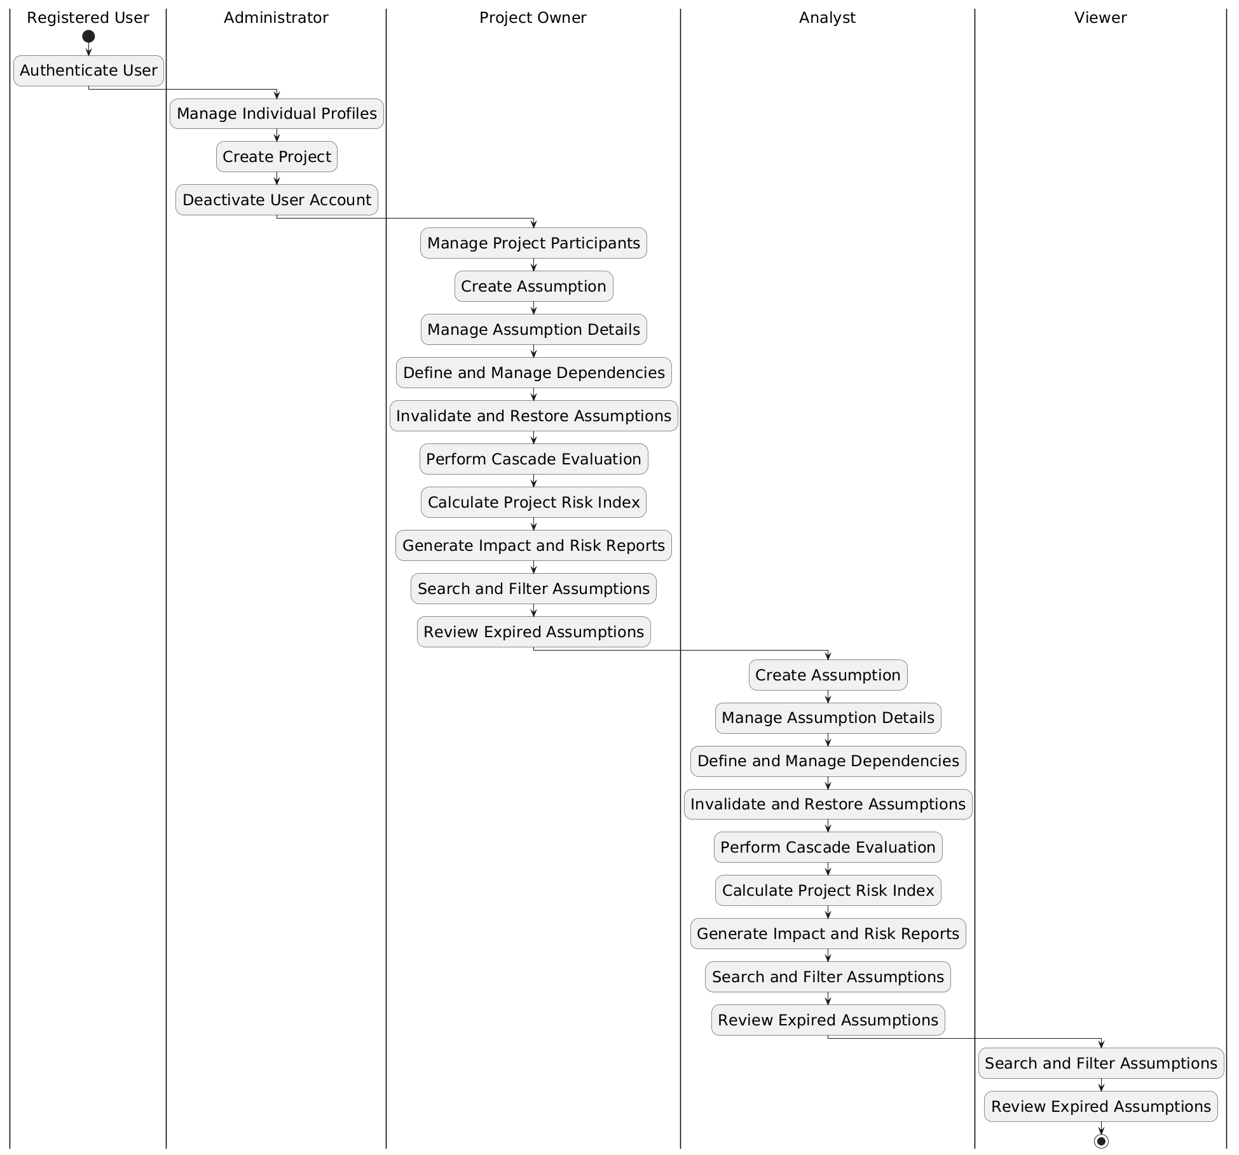
Diagram 2: Activity Diagram for “Assumption Dependency & Impact Tracking System (ADITS)”

